**Career Summary**

* 8 years of experience in network protocols, Firewalls and Communication Network design.
* In-depth Cisco technology knowledge in design, administration, implementation and support.
* In-depth knowledge of deploying and troubleshooting IP protocols.
* Experience on layer 3 routing and layer 2 switching.
* Dealing with escalating problems.
* Efficient use of Microsoft VISIO as technical documentation and presentation tools.
* Excellent experience in Network Planning, Implementing, Configuring, Troubleshooting and Testing of networking system.
* In depth knowledge of networking
* Excellent communication and presentation skills
* Good analytical abilities
* Confident
* Patient and polite
* Adaptive to environment

**Technical Skills**

**Network Management :** SNMP, Cisco Works, Kiwi-cat, What's-Up Gold, Ethereal  
**Platforms :** Cisco IOS(11.x, 12.x), PIX IOS(6.x, 7.x), CAT-OS UNIX, LINUX,  
**Operating systems :** Windows XP, NT, 2000, 2003  
**Programming language :** C, C++, HTML  
**Routing Protocols :** RIP, IGRP, EIGRP, OSPF, IS-IS, BGP,HSRP, VRRP & GLBP  
**Infrastructure services :** DHCP, DNS, SMTP, FTP, TFTP  
**LAN technologies :** Ethernet, Fast Ethernet, Gigabit Ethernet & 10 Gigabit Ethernet  
**Port :** channel, VLANS, VTP, STP, RSTP, 802.1Q  
**WAN technologies :** Frame Relay, ISDN, ATM, MPLS, leased lines & exposure to PPP, DS1, DS3, OC3, T1 /T3 & SONET

**Professional Certification**

* Cisco Certified Network Professional: (CCNP)
* Juniper JNCIA Certified

**Key Responsibilities Handled**

* Working on PIX (506, 515, 525, 535), ASA (5505/5510) Firewalls.
* Implementing security policies using ACL, Firewall, IPSEC, SSL, VPN, IPS/IDS, AAA (TACACS+ & RADIUS)
* Dealt with monitoring tools like network packet capture tools like Wire-shark, etc.
* Installation, Configuration and Administration of Windows Servers 2000/2003, Active Directory, FTP, DNS, DHCP, TFTP, Linux OS under various LAN and WAN environments.
* Migration of existing IPSEC VPN tunnels from Pre-Shared key to Certificate.
* Network redesign for branches / Campus Locations.
* Changing both the voice and data environment.
* Replacing branch hardware with new 2851 routers and 2960 switches.
* Performing security audits of perimeter routers, identifying missing ACL’s
* Troubleshooting of complex LAN/WAN infrastructure, including routing protocols EIGRP, OSPF & BGP.
* Lab testing & validation prior to implementation of Nexus 7K, 5K & 2K connecting to blade servers.
* Settings of the networking devices (Cisco Router, switches) co-coordinating with the system/Network administrator during implementation.
* Configuring network access servers and routers for AAA Security.
* Documentation and change control.
* Working on troubleshooting of complex LAN/WAN infrastructure.
* Administration of Cisco 11.x and 12.1 versions.
* Monitoring all Cisco equipment’s using Cisco Works.
* Involved in SNMP Network management.
* Working on various scanning and Sniffing tools like Ethereal.
* Upgrading and backups of Cisco router configuration files.
* Implementing and maintaining backup schedules.

**Employers**

* JQ technologies ltd. from 20** to till date as Sr. Network Engineer
* HI Pvt. Ltd. from 20** to 20** as Network engineer executive

**Routing / WAN:** EIGRP, OSPF, RIP, BGP, PBR, route redistribution, IP Routing, HDLC, PPP, Multilink, ISDN, VoIP, QoS.  
**Switching:** Vlan, VTP, STP, Ether channel, HSRP, VRRP, GLBP.  
**Security:** ACL, NAT, VPN IPSec Tunnel, GRE Tunnel, 802.1x, Port Security, Firewalls, TACACS.  
**NMS / Analysis:** Cisco works 5.0, IPSwitch what’s up Gold, MRTG, Solarwind Network engineer toolset, Netflow analyzer, Kiwi Syslog, Visio.  
**Hardware:** Catalyst 2960 / 3550 / 3750 / 4500 / 6500 series switches, 3845 / 3745 / 2821 / 2600 Series Cisco routers, Cisco ASA 5520, PIX 535, Checkpoint r65, Nortel 3120 router, Nortel 8300 / 4548.  
**Operating Systems:** Cisco IOS, Windows Server 2003 / 2000 / NT and Workstation 98 / XP / 2000.  
**Network Tools:** AlterPoint, NetQOS  
**Management:** ITIL training

**PERSONAL QUALITIES**

* Good managerial skills.
* Optimistic.

**KEY RESPONSIBILITIES HANDLED**

* Providing L2 and L3 network support to Siemens LOB’s, Forest Laboratories and Grifols.
* Working on Clarify and Remedy ticketing system to address customers Network related issues.
* Working with Cisco TAC on escalated issues.
* Troubleshooting various network related issues with Service providers (Orange, Verizon, AT&T, and Time Warner Cables).
* Firewall and router configuration changes as per the business requirement.
* Conducting root cause analysis on Network Incident.
* Work for permanent solution on reoccurring network Incidents.
* Making emergency changes in the network to ensure uninterrupted services.
* Documenting network changes and updating diagrams accordingly.
* Working with third party vendors for new project implementations related to network support.
* Additional responsibilities include creating Work Level Instruction (WLI).
* Architected and Integrated back-end and network infrastructure with an emphasis on scalability, availability, security and manageability.
* Designed and deployed networks using dynamic routing protocol (EIGRP, OSPF and BGP).
* Communicated with local and foreign telecom bodies for procuring and commissioning of various local, IPLC and ISDN circuits to support and data/voice application.
* Developed and documented network diagrams and procedures.
* Devices used PIX 535 v7.0, ASA 5520, routers 2600, 2800, 3700 3800 series, switches 6500, 4503, 2960, 3548 series.
* IPSec VPN tunnel over public network.
* Implementation of Cisco H.323 VoIP Gateway.
* Implementation of QoS on IGT network.

**KEY PROJECT UNDERTAKEN**

* Network Infrastructure Design and Implementation from the ground level for new site XXXX.
* Remotely commanded and coordinated with XXXX team for new site setup XXXX.
* Network Infrastructure Design and Implementation for XXXX centre at XXXX.

**ACHIEVEMENT**

* Stayed under budget for many quarters.

**EMPLOYERS**

**1. Company Name:** XXXX IT solution and services Pvt.Ltd.  
**Duration:** Since OCT 20XX  
Designation: Senior Systems Engineer for Network Operations  
  
**2. XXXX**  
**Duration:** From June 20XX to September 20XX  
**Designation:** Sr. Network Engineer

**ACADEMIA**

* Bachelor of commerce, University 1 (20XX)
* XII from XXXX School (20XX).
* X from XXXX School (19XX).
* 1 year Diploma in computer application from XXXX Technical College

**TECHNICAL CERTIFICATION**

* CCNP – Routing and Switching (Cisco Certified Network Professional)
* MCP (Microsoft Certified Professional) in windows 2003 server
* CCNA (Cisco Certified Network Associate)
* CCSA (Check Point Certified Security Administrator) training
* A+ Certification

**PERSONAL DETAILS**

**Date of Birth:** 11th January 19XX  
**Languages known:** English, Hindi and Malayalam  
**Addres**

* 8 years of experience in network protocols, Firewalls and Communication Network design.
* In-depth Cisco technology knowledge in design, administration, implementation and support.
* In-depth knowledge of deploying and troubleshooting IP protocols.
* Experience in layer 3 routing and layer 2 switching.
* Dealing with escalating problems.
* Efficient use of Microsoft VISIO as technical documentation and presentation tools.
* Excellent experience in Network Planning, Implementing, Configuring, Troubleshooting and Testing of networking system.

**Skills Set**

* In depth knowledge of networking
* Excellent communication and presentation skills
* Good analytical abilities
* Confident
* Patient and polite
* Adaptive to environment

**Technical Skills**

**Network Management:** SNMP, Cisco Works, Kiwi-cat, What's-Up Gold, Ethereal  
**Platforms:** Cisco IOS(11.x, 12.x), PIX IOS(6.x, 7.x), CAT-OS UNIX, LINUX,  
**Operating systems:** Windows XP, NT, 2000, 2003  
**Programming language:** C, C++, HTML  
**Routing Protocols:** RIP, IGRP, EIGRP, OSPF, IS-IS, BGP,HSRP, VRRP & GLBP  
**Infrastructure services:** DHCP, DNS, SMTP, FTP, TFTP  
**LAN technologies:** Ethernet, Fast Ethernet, Gigabit Ethernet, & 10 Gigabit Ethernet  
**Port:** channel, VLANS, VTP, STP, RSTP, 802.1Q  
**WAN technologies:** Frame Relay, ISDN, ATM, MPLS, leased lines & exposure to PPP, DS1, DS3, OC3, T1 /T3 & SONET

**Professional Certification**

* Cisco Certified Network Professional: (CCNP)
* Juniper JNCIA Certified

**Key Responsibilities Handled**

* Working on PIX (506, 515, 525, 535), ASA (5505/5510) Firewalls.
* Implementing security policies using ACL, Firewall, IPSEC, SSL, VPN, IPS/IDS, AAA (TACACS+ & RADIUS).
* Dealt with monitoring tools like network packet capture tools like Wire-shark, etc.
* Installation, Configuration and Administration of Windows Servers 2000/2003, Active Directory, FTP, DNS, DHCP, TFTP, Linux OS under various LAN and WAN environments.
* Migration of existing IPSEC VPN tunnels from Pre-Shared key to Certificate.
* Network Redesign for branches/Campus Locations.
* Changing both the voice and data environment.
* Replacing branch hardware with new 2851 routers and 2960 switches.
* Performing security audits of perimeter routers, identifying missing ACL’s
* Troubleshooting of complex LAN/WAN infrastructure, including routing protocols EIGRP, OSPF & BGP.
* Lab testing & validation prior to implementation of Nexus 7K, 5K & 2K connecting to blade servers.
* Settings of the networking devices (Cisco Router, switches) co-coordinating with the system/Network administrator during implementation.
* Configuring network access servers and routers for AAA Security.
* Documentation and change control.
* Worked on troubleshooting of complex LAN/WAN infrastructure.
* Administration of Cisco 11.x and 12.1 versions.
* Monitoring all Cisco equipment’s using Cisco Works.
* Involved in SNMP Network management.
* Working on various scanning and Sniffing tools like Ethereal.
* Upgrading and backups of Cisco router configuration files.
* Implementing and maintaining backup schedules.
* Experienced Cisco Network Engineer with more than X years.
* Experienced in working interactively with customers and all levels of management.
* Hands on routing and switching.
* Strong technical concepts.

**TECHNICAL SKILLS**

**Routing/WAN:** EIGRP, OSPF, RIP, BGP, PBR, route redistribution, IP Routing, HDLC, PPP, Multilink, ISDN, VoIP, QoS.  
**Switching:** Vlan, VTP, STP, Ether channel, HSRP, VRRP, GLBP.  
**Security:** ACL, NAT, VPN IPSec Tunnel, GRE Tunnel, 802.1x, Port Security, Firewalls, TACACS.  
**NMS/Analysis:** Cisco works 5.0, IPSwitch what’s up Gold, MRTG, Solarwind Network engineer toolset, Netflow analyzer, Kiwi Syslog, Visio.  
**Hardware:** Catalyst 2960/ 3550 / 3750/ 4500 / 6500 series switches, 3845/ 3745/ 2821/2600 Series Cisco routers, Cisco ASA 5520, PIX 535, Checkpoint r65, Nortel 3120 router, Nortel 8300/4548.  
**Operating Systems:** Cisco IOS, Windows Server 2003/2000/NT and Workstation 98/XP/2000  
**Network Tools:** AlterPoint, NetQOS  
**Management:** ITIL training

**PERSONAL QUALITIES**

* Good managerial skills.
* Optimistic.

**KEY RESPONSIBILITIES HANDLED**

* Providing L2 and L3 network support to Siemens LOB’s, Forest Laboratories and Grifols.
* Working on Clarify and Remedy ticketing system to address customers Network related issues.
* Working with Cisco TAC on escalated issues.
* Troubleshooting various network related issues with not only limited to Service providers (Orange, Verizon, AT&T, and Time Warner Cables).
* Firewall and router configuration changes as per the business requirement.
* Conducting root cause analysis on Network Incident.
* Work for permanent solution on reoccurring network Incidents.
* Making emergency changes in the network to ensure uninterrupted services
* Documenting network changes and updating diagrams accordingly.
* Working with third party vendors for new project implementations related to network support.
* Additional responsibilities include create Work Level Instruction (WLI).
* Architected and Integrated back-end and network infrastructure with an emphasis on scalability, availability, security and manageability.
* Designed and deployed networks using dynamic routing protocol (EIGRP, OSPF and BGP).
* Assisting with establishing IGT NOC to proactively monitor the network resulted in better SLA and network performance, network infrastructure and network security.
* Communicated with local and foreign telecom bodies for procuring and commissioning of various local, IPLC and ISDN circuits to support and data/voice application.
* Developed and documented network diagrams and procedures.
* Devices used PIX 535 v7.0, ASA 5520, routers 2600, 2800, 3700 3800 series, switches 6500, 4503, 2960, 3548 series.
* IPSec VPN tunnel over public network.
* Implementation of Cisco H.323 VoIP Gateway.
* Implementation of QoS on IGT network.

**KEY PROJECT UNDERTAKEN**

* Network infrastructure design and Implementation from the ground level for new site XXXX.
* Remotely commanded and coordinated with XXXX team for new site setup XXXX.
* Network infrastructure design and Implementation for XXXX centre at XXXX.

**ACHIEVEMENT**

* Stayed under budget for many quarters.

**EMPLOYERS**

**Company Name:** XXXX IT solution and services Pvt.Ltd.  
**Duration:** Since OCT 20XX  
**Designation:** Senior Systems Engineer for Network Operations  
  
**Company Name:** XXXX  
**Duration:** From June 20XX to September 20XX  
**Designation:** Sr. Network Engineer

**ACADEMIA**

* Bachelor of commerce, University XXXX (20XX)
* XII from XXXX H.S.School (20XX).
* X from XXXX H.S.School (19XX).
* 1 year Diploma in computer application from XXXX Technical College

**TECHNICAL CERTIFICATION**

* CCNP – Routing and Switching (Cisco Certified Network Professional)
* MCP (Microsoft Certified Professional) in windows 2003 server
* CCNA (Cisco Certified Network Associate)
* CCSA (Check Point Certified Security Administrator) training
* A+ Certification
* **Cisco network engineer resume**
* Sishir Roy  
  Email ID- *****@gmail.com   
  Contact No.+91-******  
    
  Career Summary-  
    
  To work in the field of Networking & looking forward to an exciting and challenging career with an organization  
  that provides excellent working environment and opportunities.  
    
  Career Summary-  
    
  - Six plus years of work experience in Networking Field.   
  - Proficient in WAN and LAN technologies.   
  - Expert in configuring and installing CISCO Routers and switches.  
  - Proficient in monitoring and troubleshooting the Network / Link in case of any breakdown.   
  - Extensive hands-on experience in network integration, deployment and Support.   
  - Good process knowledge about Incident Management, Change and Problem Management.  
    
  Key Responsibilities Handled-  
    
  - Coordinating with Branch office Site contact to understand the site specific Network devices and connectivity.  
  - Preparing the Task list for remote sites implementation steps with timelines and owners  
  - Preparing the Activity list and configuration backup, fallback plan and test cases  
  - Responsible for configuration of network devices used to design the service.   
  - Maintaining & Troubleshooting 30 Nos L2 LAN switches. (Cisco 3750 Series)   
  - Maintaining & Troubleshooting Cisco Wireless Access point in Ford entity.   
  - Maintaining Video Conference system using 128 Kbps ISDN link.  
  - Troubleshooting Cisco 7910, 7912, 7936, 7940, 7960 IP Phones.  
  - Maintaining licence and Configuring Cisco Soft IP Phones with onsite team.  
  - Procurement and commissioning of the leased line.  
  - Configuring the MLLN, MPLS-VPN, Point to point   
  - Leased line and ISDN Circuits in CISCO Routers.  
  - Installation of various types of MODEMS for Leased Lines and ISDN.  
  - Monitoring and connectivity of all these links, preparing reports and troubleshooting incase of link down.  
  - Monitoring and maintaining the 18 Branches leased line and ISDN links at central site Location.  
  - Preparing and sending the daily down time and utilization report.  
  - Commissioning and troubleshooting the links in case of any breakdown.  
    
  Technical Knowledge-  
    
  - CISCO Routers - 1700, 1800, 2621, 2821 and 3725, 7206 series.  
  - CISCO Switches - 1900, 2900, 2960G, 3750, 4006,6506, 6509,6513 series.  
  - MODEMS - ASM 20, ASM 31, HTU-E1, Tellabs 8110, ASM-i52, RAD, CYGNUS.  
  - WAN TECHNOLOGIES – Leased line, MPLS VPN, MLLN, ISDN-BRI, ATM, FRAME RELAY, ISDN, ADSL, CARRIER ETHERNET   
  ATM and FRAME RELAY NETWORK.  
  - Configuring Static and RIP, IGRP, EIGRP, OSPF, BGP, IS-IS Routing protocols.  
  - Configuring PPP, HDLC, Access, Trunk and encapsulation .  
  - LAN TECHNOLOGIES – Ethernet, Switching, VLAN, and Assign port speed, Duplex, Cisco IOS & CatOs up gradation   
  and change request (CCR).   
  - Knowledge on IEEE 802.1q, VTP, STP, PVST,MST, RSTP, HSRP, GLBP,VRRP, Ether-Channel, CEF  
    
  Achievements-  
    
  - Installed successfully network to the FGH services.  
  - Got Best Employee reward in 2011.  
    
  Employer-  
    
  - Working from May 2011 to till as Date Senior Engineer–Network management in ERT Pvt. Ltd.  
  - Worked from Mar 2010 to Apr 2011 as Infrastructure Management Associates in RGH Solutions.  
  - Worked from Feb 2007 to Feb 2010 in ZXC Pvt. Ltd. as Senior Network Engineer.  
  - Worked from 2004 July to 2006 Mar in LPY Pvt. Ltd. as Network Support Engineer.  
    
  Academia-  
    
  - B.C.A in correspondence at WER University.  
  - Diploma in Electronics and Communication Engineering RTY Polytechnic  
  - SSLC (1997 – 1998) RTY Secondary School.  
    
  Personal Details  
    
  Date Of Birth : MM/DD/YYYY  
  Gender : Male  
  Marital Status : Single

isco network engineer resume -1  
  
Prateek Bajpai  
pbajpai123@gmail.com  
  
  
Rajiv Pal  
Email ID- ****@gmail.com   
Contact no. +91-******  
  
Career Objective-  
  
Looking to join a progressive organization/MNC that has the need for a Network Engineer with Cisco certification & expertise and offers opportunities for advancement.  
  
Career Summary-   
  
- Expertise in Routing , Switching ,Firewalls , network configuring, troubleshooting & designing   
- Network Engineer with total 10 years experience   
- CCNA & CCNP Certified   
- JNCIA (Juniper)certified   
- Expertise in Cisco,Juniper & Checkpoint technologies.  
- Experience from multi cultural ,MNC , overseas & highly process oriented environments.  
  
Personality Traits-  
  
- Strong assessment/analyzing,   
- Troubleshooting & problem resolving skills.  
- Team player/leader; Capable of integrating with and developing effective workgroups.  
- Excellent verbal & written communication skills.   
- Able to relate well with people.   
  
Key responsibilities handled-  
  
- Identify and resolve problems on high end Switches, Routers(Cisco & Juniper),FWSM,ASA & Checkpoint firewalls.  
- New build support for the build activities in data centers LAN/WAN.  
- Administration ,trouble shooting & new implementations on Cisco 6500 series switches, Nexus switches, Cisco   
Routers ,Juniper devices, checkpoint & ASA firewalls.  
- Administration of network devices holding more than 5000 servers of Windows, Unix &Linux platforms (physical   
& virtual servers).  
- Trouble shooting incidents of different levels of severity by working with the OS ,Customer and application  
teams.   
- Implementation & trouble shooting of complex wan,lan,vlans ,private vlans,high availability solutions like   
hsrp , ether channels, site to site vpn, access control lists, NAT,PAT ,routing solutions etc  
- Plan and implement complex network changes as per ITIL specifications.  
- Managing Security, tier 3 support.  
- Creation of fire wall policies as per the requirements on Checkpoint,ASA, FWSM, Juniper firewalls.  
- Conduct Knowledge transfer trainings to newly hired resources in the team.  
- Managing Cisco Layer 2 ,Layer 3 switches & Routers on the network.  
- Resolving routing and switching related real time performance issues   
- Implementation & trouble shooting of vlans, high availability solutions like hsrp , ether channels, SSL vpns, access control lists, NAT,PAT ,routing solutions etc  
- Configuration & Management of VLANs ,802.1q trunks, VTP, Security policies   
- Installation and configuration of new devices on LAN   
- Trouble shooting real time issues working with team  
- Creation & Implementation of new security rules on fire walls   
- ACLs management on switches & routers , managing inter vlan communications  
  
Technical Skills-  
  
Servers :Catalyst 45XX,6509,6506,3750,3550,3725,2950,2960,Nexus 5010, 5020 etc  
IPSec, Site to Site VPN protocols, GRE, Tunneling   
Frame relay ,PPP, MPLS  
FWSM,ASA, Checkpoint & Juniper  
OS- AIX ,Solaris, Linux, Windows   
VMs- VIO & LPARS, ESX & Vmware  
  
Employer-  
  
- Working from May 2011 – till date in GHJ Corp. as Network Engineer(Desgn: Network Support Specialist).  
- Worked from Feb2009-Mar2011 in ASD Embassy as Administration & Technical Support Team Member.  
- Worked from Jul 2007 –Aug 09 in MNO Services as Technical Support Engineer  
- Worked from Aug 2002-04 in DFG College as Lecturer in department of Electronics & communication   
  
future plan-

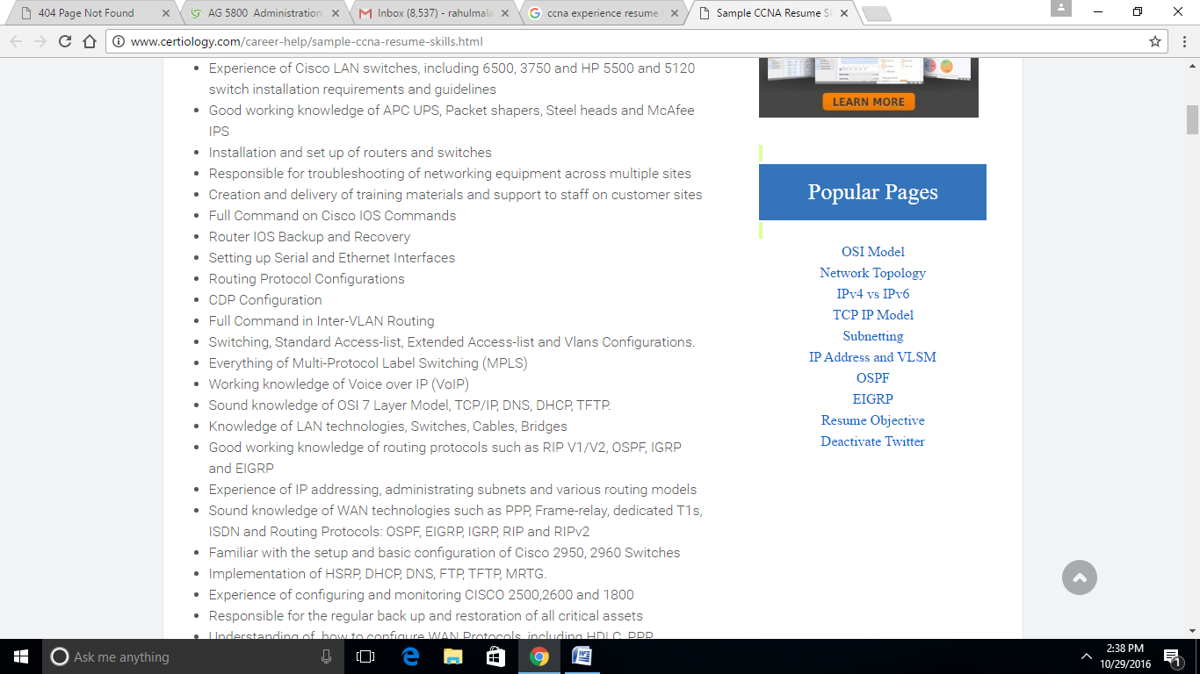

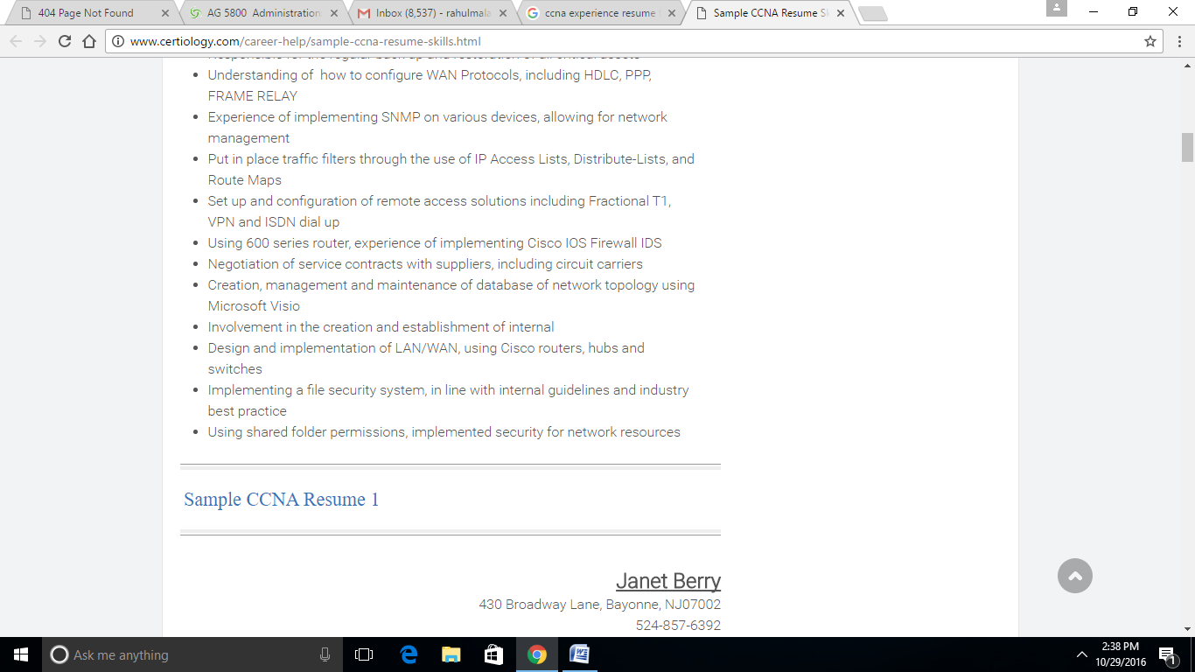

**Career Objective**

Looking for challenging duties in an expert environment that makes use of my analytical, problem-solving abilities, expertise and specialized information, for the mutual development of my career and the business.

**Experience Summary**

* Senior Network Engineer at Stylogic Systems from August 2013 to January 2014.
* Systems Network Engineer for Agricom Corporation from March 2010 to July 2013.

**Expertise Summary**

* 8 years of all-inclusive experience in System and Network Administration
* Experience in testing, installation and troubleshooting of Cisco ISR 1800,2800,3800 and

**Cisco 7206 Routers**

* Proficiency in installing and troubleshooting Catalyst 2960,3750,3560,6506 Switches
* Qualified in installation and troubleshooting of Cisco 7940,Nortel NTDU92 VOIP phones
* High capability and expert knowledge in Routing and Switching.

**Certifications**

* Cisco Certified Network Associate (CCNA)
* Cisco Id: CSCO911411959

**Products Handled**

* **Routers           : Cisco**(**ISR)**1800,2800,3800 and 7206
* **Switches         : Catalyst**2960,3750,3560,6506

**Experience Profile**

**Senior Network Engineer**in **Stylogic Systems**From**AUGUST 2013**to **JANUARY 2014**

**Roles and Responsibilities**

* Managed a community of 200 Places throughout the US.
* Configuring and Troubleshooting BGP
* Configuring Access controls that are opensource for AAA services
* For creating connectivity with internet service provider in place gateways configuring routers
* Executing routers for creating connectivity with Nodes for every region.
* Configuring routers for inter-office connectivity
* Session administration on Accessibility Control devices
* Bandwidth limitation for clients and supplying QOS for clients.
* Vlan established bandwidth allocation for particular users depending on user’s strategy
* Creating reports on user complaints and problems fixed
* Preparation & scheduling the support and community downtime for assorted upgrades and care
* Delivering preventive care and pro-active monitoring for many places

**Systems Network Engineer**for **Agricom Corporation.**From**March 2010 to July 2013**

**Roles and Responsibilities**

* Managed the network links for 10 US regions.
* Logged call-ins and supervised resource allocation for any region break downs
* Configured load-balancing with router on Cisco routers for redundancy function
* Used VRRP.to tracking and troubleshoot OFC and MLLN established connectivity on regional offices
* Provided resolutions for physical break downs of copper-based media types or OFC by coordinating with all the teams.
* Supplied looping to keep connectivity, in the event of any physical media collapses
* Converting the linking system from non-leased line to Manageable Leased Line Network.
* Delivering preventive care and pro-active monitoring for all the regions.
* Preparation & scheduling the community downtime for maintenance and assorted improvements

**Education**

* Bachelors in Electronics & Communication Engineering              2007     GPA: 3.82

**Languages Known**

* Fluent in English and Spanish

 Sample CCNA Resume 3

**Douglas Kane**

● 65 Glenview Avenue, Grand Rapids,NJ08863●  
●Phone:(584) 723-7993 ●E-mail:[dougkane@gmail.com](mailto:dougkane@gmail.com%20)●

**Network and Security Engineer**

**Cisco Networks ● Cisco and Checkpoint Firewalls**

Highly accomplished Network and Security engineer with 5 years of experience in multistage networking projects.

Exceptional customer service and communication skills. Strong problem solving capabilities using historical knowledge, logical and systematic approaches.Ability to work in a team setting or independently. Polished presentation skills. Superior writing and verbal communication skills.

**Recognized for out standing competence in following areas:**

* **Leadership:** Commended by business executives, co-workers, and equals for skill and powerful work ethic to complete jobs that were incredibly complicated on program.
* **Technical:**Successfully models highly scalable redundant and safe network environments using software revisions and most present hardware from leading sellers.
* **Documentation:**Creates simple to follow step by step procedural instruction manual and simple to study person Visio diagrams.
* **Communication:**By using PowerPoint demonstrations and excellent writing and communicating abilities economically, sophisticated technical material is delivered to nontechnical company place direction.

**Technical Skills**

**Hardware:**  
Cisco routers: 2600,2800,3600,3800,7200

Cisco switches: 3550, 3560 X, 4500,4900, 6500 SUP  
2A/720

Cisco fire walls: PIX 500/ASA 5500 v.7.0-v.8.2

Cisco VPN concentrators: 3020-3060

Cisco Nexus switch family: 1000 v,2000,5500,7000,  
4000i

**Software:**  
Cisco CatOS, IOS, SANOS, NXOS

Cisco SAN Fabric directors MDS 9509/9513

Cisco SAN Edge switches MDS 9140/9124/9134/9148

Windows,Unix, and Linux operating systems.

**Professional Experience**

**May 2008–Present             ABC Networks Inc.              Union City,NJ**

**Systems Networking Communications Engineer**

* Supply critical and specialized network analysis of WLAN infrastructure and the existing campus LAN
* Analyze, support, plan, execute and organize updates of network change applications as needed
* Assess the present network infrastructure and layout
* Carry out and organize modifications to streamline reporting, tracking, and community administration
* Execute current network management system and document management practices that are implemented
* Ensure back-up of network part settings to make sure there is capacity to quickly replace neglected network equipment which includes documentation of practices that are enforced
* Upgrade, streamline, and record baseline settings for network switches
* Review network change settings to make sure access interface settings and appropriate uplink to help QoS and VoIP
* Supply changeover information and on-going functional support of fluctuating levels of difficulty to customer sand networking staff
* Assist personnel as-needed for all telecommunication and network components
* Collaborate and talk to contracted sellers to offer support of distribution layer refresh and the network core.
* Supply layout, technical assistance and arrangement of the wireless network infrastructure that is existing
* Provide assistance and appraisal of the campus VoIP telephony program
* Create source materials and technical documentation that offer informal everyday training for networking staff
* Perform networking responsibilities as assigned

**Education**

Designing Cisco Storage Networking Solutions  
(DCSNS)v.4.2

Securing Network swith ASA Advanced  
(SNAA)

Securing Network swith ASA Fundamentals  
(SNAF)

CCNA-Cisco Certified Network Associate

2013 Global Knowledge, NewYork,NY

2011 Global Knowledge, Morristown,NJ

2009 Global Knowledge, NewYork,NY

2007 Global Knowledge, NewYork,NY